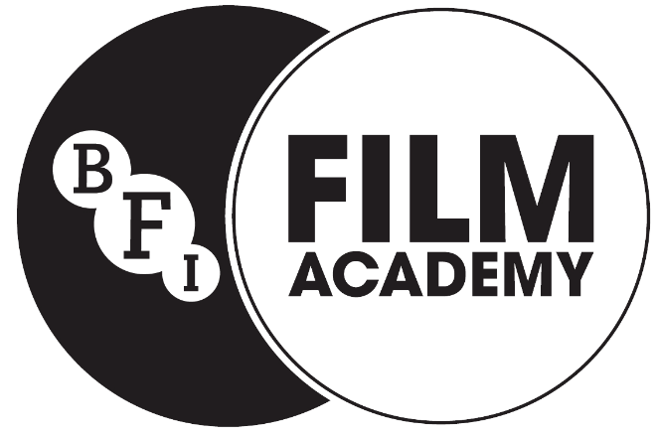

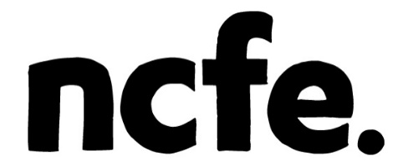

Preparing to Work in the Film Industry
Participant Handbook

NCFE Level 2 Award in Preparing to Work in the Film Industry
(601/4488/9)



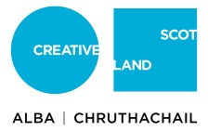


The Qualification
At the BFI Film Academy you will gain a qualification in ”Preparing to Work in the Film Industry” which is accredited by NCFE. This qualification has been designed by BFI to provide you with an understanding of what it’s like to work in the film industry. It also gives you the opportunity to gain and develop relevant skills in planning and producing a practical film-based project.

Your Portfolio
To gain the qualification you will create a portfolio of evidence to show your learning throughout the BFI Film Academy. This can either be paper based or produced online and can include the following:
- A workbook/journal
- Video or written blogs
- Finished films and other video content
- “Behind the scenes” film or footage
- Audio recordings
- Annotated drawings and notes
- Worksheets and diagrams
- Scripts
- Photographs
- Presentation slides
- Professional and Assessor written observations and feedback

Academy Support and Feedback
You will have a dedicated NCFE assessor who will support you throughout the BFI Film Academy and provide feedback on the evidence you produce for the NCFE qualification. The portfolio is not graded, you will gain feedback on each section and have the opportunity to add further evidence should it be required. If you have any additional needs or requirements, let your Assessor know and they will be able to offer you further support.

NCFE Support for participants
If you have an issue or complaint then you should raise your concerns with the academy you have attended directly and follow their complaints procedure. If the issue is not resolved you can contact NCFE.
https://www.ncfe.org.uk/learners/complaints#Search

Plagiarism
All the work evidenced in your portfolio must be your own. As part of completing the qualification you are asked to sign a participant agreement stating that the work you have submitted is not copied.
Plagiarism is using the work of another person without crediting the source. BFI Film Academy assessors regularly check work produced to ensure it is original and not copied.
If a participant produces work that is plagiarised then learner achievements may be withheld or additional work may need to be submitted by the participant.
For more information about the NCFE policy on plagiarism:
https://forms.ncfe.org.uk/media/834862/plagiarism-guidance-200318.pdf

Preparing to Work in the Film Industry

- Technical Skills
Developing your technical skills – this can be in a chosen specialist area including acting, animation, camera, directing, producing, production design, sound and writing.
Topics Covered:
- Developing Your Skills
- Identifying Skills, Equipment and Resources Required
- Receiving Feedback on Your Role
- Reviewing Your Own Skills Development

- Professional Development Opportunities

Understanding what it’s like to work in the film industry, the different jobs and roles that exist, how the roles work together and how you can take the next step.

Topics Covered:

- The Working Culture of the Film Industry
- Departments and Roles
- Personal Progression Plans

- Working Relationships

Understanding how important collaborative working in the film industry is and how to develop your skills in team working.

Topics Covered:
- The Importance of Teamwork
- Qualities Needed to Work Well with Others
- Your Collaborative Working

- Working Practices and Legislation
Working safely during your film production and making sure you don’t break the law.
Topics Covered:
- Health and Safety
- Copyright and Clearances

- Review Films

Review the creative decisions made in short film productions.

Topics Covered:
- Film Theory (Narrative, Use of Camera, Editing and Sound Design)

